APPLICATION FORM

Thank you for the interest shown in Virtusa. Please take a few minutes of your time to fill in the following details to help us understand your technical skills and personal competencies better.
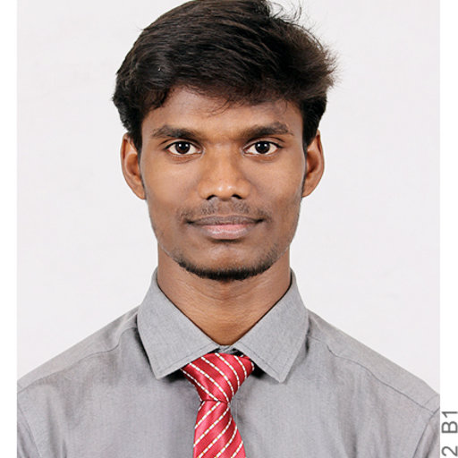Paste your Passport Size Photograph
Please keep in mind the following when filling up the form:

- Fill in the boxes in the application blank in bold capital
letters unless the content is of a descriptive nature.

- Fill in the details according to the format mentioned
for the date and day.

NAME (As in Passport) |  | VIGNESH ARVIN GOVINDHARAJ  ___________________________________/_____________________________________  Given Name Surname
Former Name (s) / Maiden Name (if applicable)
Father’s Name: GOVINDHARAJ
Nationality: INDIAN |  |  | Social Security Number (if applicable): NA
Sex: MALE |  |  | Marital Status: UNMARRIED
Date of Birth: ___19___/___10_____/____1997________  DD MM YY |  |  |  | Place of Birth: PALACODE
ADDRESS | Present Address |  |  |  | Permanent Address
House No | 3/396 |  |  |  | 3/396
Locality / City | SUGARMILL, PALACODE |  |  |  | SUGARMILL, PALACODE
State | TAMIL NADU |  |  |  | TAMIL NADU
PIN CODE | 636808 |  |  |  | 636808
Period of Stay | 19/10/1997 to 15/12/2021 |  |  |  | 19/10/1997 to 15/12/2021
 (Telephone) | NA |  |  |  | NA
 (Mobile Phone) | +91 9600914154 |  |  |  | +91 9600914154
E-mail ID (Personal) | ARVIN.VIGNESH@GMAIL.COM
Instant Messaging System ID: NA

Passport Details: |  | Available | YES | Not Available |  | Applied
Number | : | T4582249
Date Of Issue | : | 06/06/2019
Date of Expiry | : | 05/06/2029
Place Issue | : | COIMBATORE
 |  |  |  |  |  |  | Yes |  | No
Do you have a valid Car Driving License |  |  |  |  |  |  |  |  | NO
Have you had any visa rejections? If yes, please mention the nature of visa & reason for rejection. |  |  |  |  |  |  |  |  | NO
Are you open to Travel to the USA / Sri Lanka on work for a period of 6 mths/less during a year? |  |  |  |  |  |  | YES

S.No | Languages Known | Read | Write | Speak
1 | TAMIL | YES | YES | YES
2 | ENGLISH | YES | YES | YES
3 | HINDI | YES | YES | NO
4
Family Information (Parents, Brothers, Sisters, Spouse & Children)
S.No | Name | Relationship | Date of Birth | Age
1 | M.G.GOVINDHARAJ | FATHER | 05/02/1973 | 48
2 | G.GOVIND | MOTHER | 22/10/1978 | 43
3 | M.G.THILAGAVATHI RAJ | SISTER | 01/09/1995 | 26
4
5

EDUCATION INFORMATION
Degree | Course | Program (full-time/Part-time) | Elective | College Name and Address | University Name and Address | Duration |  | % | Graduation Date (MM/YY)
X | SSC | FULL TIME | NO | D.D.C.S.M.MATRICULATION SCHOOL, SUGARMILL | STATE BOARD, TAMIL NADU | 2012 | 2013 | 96.4 | 03/2013
XII | HSSC(MATHS-BIO) | FULL TIME | YES | SRI VIDYA MANDIR MATRICULATION HR SEC SCHOOL, PALACODE | STATE BOARD, TAMIL NADU | 2014 | 2015 | 94.83 | 03/2015
Graduation | B.E, EEE | FULL TIME | YES | KUMARAGURU COLLEGE OF TECHNOLOGY, COIMBATORE | ANNA UNIVERSITY, CHENNAI | 2015 | 2019 | 77.8 | 04/2019
PG | NA | NA | NA | NA | NA | NA | NA | NA | NA
Others 1

SSN No. (mandatory if studied in USA or Canada):

* Please mention the last full time degree

ADDITIONAL QUALIFICATIONS/ DIPLOMAS / CERTIFICATES / TRAINING
Please mention any Self learned course /Software /Package)
Program | Institute | Duration |  | % | Division
NA | NA | NA | NA | NA | NA

SEMINARS / TRAINING PROGRAMS ATTENDED
S.No | Seminar / Training Program | Conducted by | Duration
S.No | Seminar / Training Program | Conducted by | From | To
1 | NA | NA | NA | NA

MAJOR ACHIEVEMENTS /PUBLICATIONS TO YOUR CREDIT
S.No |  | Description |  |  |  |  |  |  |  |  | Year
1 |  | NA |  |  |  |  |  |  |  |  | NA
2

PROJECT INFORMATION (In ascending order give details of the recent projects)
S.No |  | Title |  | Company |  | Client | Platform and Skills used |  | Team Size | Role
1 |  | TELEFONICA  O2UK |  | NETCRACKER |  | O2UK | ANGULAR2+, JAVA  OSGI BUNDLE  FRAMEWORK |  | 12+ | SOFTWARE ENGINEER
2 |  | RSA_KAIZEN |  | COGNIZANT TECHNOLOGY  SOLUTIONS |  | RSA  MIDDLE  EAST | ANGULAR 2+, JAVA  SPRINGBOOT, IBM WAS  SERVER |  | 70+ | PROGRAMMER ANALYST
3 |  | ASSETSERVDAM_  J AND J |  | COGNIZANT TECHNOLOGY  SOLUTIONS |  | JOHNSON & JOHNSON | JAVA, APACHE TOMCAT  SERVER, JMETER |  | 20+ | PROGRAMMER ANALYST  TRAINEE
4 |  | R2 PLATFORM |  | COGNIZANT TECHNOLOGY  SOLUTIONS |  | COGNIZANT TECHNOLOGY  SOLUTIONS | ANGULAR 2+, JAVA  SPRING BOOT,  MONGODB |  | 15 | PROGRAMMER ANALYST  TRAINEE
Please name two known contacts who could be friends / co-workers whom you would like to
recommend for Employment at Virtusa
 |  |  | Name |  | Current Company |  |  | E-mail address |  |  |  | Telephone
 | 1 |  | ASHWIN |  | COGNIZANT TECHNOLOGY  SOLUTIONS |  |  | ASHWINLAKSHMI9735@GMAIL.COM |  |  |  | +91 8072042519
 | 2 |  | DINESH KUMAR |  | COGNIZANT TECHNOLOGY  SOLUTIONS |  |  | RDINESHKUMAR511@GMAIL.COM |  |  |  | +91 8248665055

Details of Previous Employers (Starting from your Current Job, covering up to Last 3 Employments)

Please attach a copy of your relieving letter/service certificate for this
Company Name (1) : NETCRACKER |  | Last Designation held: SOFTWARE ENGINEER
Address (main office and branch where worked):  IBC KNOWLEDGE PARK, 4/1, TOWER D, 10TH FLOOR, BANNERGHATTA MAIN RD, BHAVANI NAGAR, S.G. PALYA, BENGALURU, KARNATAKA 560029 |  | Telephone:  080 4935 2500
Employment Period: (date, month, year)  From: 17/06/2021 To : 31/12/2021 | Employee Code/ Personnel No:  VIGO0621 |  | Name of Reporting Manager:  GAURAV KUMAR GUPTA
Name of HR:  PALLAVI DAS | Contact No. of HR:  +91 8049352500 |  | Email Id of HR:  PALLAVI.DAS@NETCRACKER.COM
Designation & Department of Reporting Manager:  TECHNICAL MANAGER,  APPLICATION MANAGEMENT DIVISION BANGALORE.GROUP4 | Contact No of Reporting Manager:  +91 9742531015 |  | Email ID of Reporting Manager:  GAURAV.GUPTA@NETCRACKER.COM
Name of Alternative Reporting Manager :  GAURAV TIWARI  Designation & Department of Alternative Reporting Manager:  DEVELOPMENT LEAD,  SEMGW.SOFTWARE ENGINEERING.PUNE.PORTAL | Contact No of Alternative Reporting Manager:  Email ID of Alternative Reporting Manager:  GAURAV.TIWARI@NETCRACKER.COM
Whether employment is of permanent or temporary nature - ◻ Permanent - YES

Agency Details (if temporary or contractual)

Remunerations (CTC pa)  6.5 LPA + 75K JB | Reason(s) for Leaving:  RELOCATION TO CHENNAI  CAREER ENHANCEMENT  TO GET INTO DEVELOPMENT ROLE

Details of Previous Employers (Starting from your Current Job, covering up to Last 3 Employments)

Please attach a copy of your relieving letter/service certificate for this
Company Name (2) : COGNIZANT TECHNOLOGY SOLUTIONS |  |  | Last Designation held: PROGRAMMER ANALYST
Address (main office and branch where worked):  TECHNO COMPLEX,5/535 OLD MAHABALIPURAM ROAD,  OKKIYAM THORAIPAKKAM, CHENNAI – 600 097. |  |  | Telephone:  4209 6000
Employment Period: (date, month, year)  From : 28/05/2019 To : 14/06/2021 | Employee Code/ Personnel No:  761024 |  |  | Name of Reporting Manager:  KIRAN KUMAR
Name of HR:  SUBRAMANIAM MANJU | Contact No. of HR:  +91 9952266105 |  |  | Email Id of HR:  MANJU.SUBRAMANIAM@COGNIZANT.COM
Designation & Department of Reporting Manager  R2 ARCHITECT,  R2 ENGINEERING | Contact No of Reporting Manager:  +91 9884290700 |  |  | Email ID of Reporting Manager:  KIRAN-6.KUMAR-6@COGNIZANT.COM
Name of Alternative Reporting Manager: NA  Designation & Department of Alternative Reporting Manager: NA | Contact No of Alternative Reporting Manager: NA  Email ID of Alternative Reporting Manager: NA
Whether employment is of permanent or temporary nature - ◻ Permanent - YES
Agency Details (if temporary or contractual)

Remunerations (CTC pa)  4.87 LPA |  | Reason(s) for Leaving:  CAREER ENHANCEMENT

Details of Previous Employers (Starting from your Current Job, covering up to Last 3 Employments)

Please attach a copy of your relieving letter/service certificate for this
Company Name (3) : |  |  | Last Designation held:
Address (main office and branch where worked): |  |  | Telephone:
Employment Period: (date, month, year)  From To | Employee Code/ Personnel No: |  |  | Name of Reporting Manager
Name of HR: | Contact No. of HR: |  |  | Email Id of HR:
Designation & Department of Reporting Manager | Contact No of Reporting Manager: |  |  | Email ID of Reporting Manager:
Name of Alternative Reporting Manager  Designation & Department of Alternative Reporting Manager | Contact No of Alternative Reporting Manager:  Email ID of Alternative Reporting Manager:
Whether employment is of permanent or temporary nature - ◻ Permanent ◻ Temporary

Agency Details (if temporary or contractual)

Remunerations (CTC pa) |  | Reason(s) for Leaving

Please account for any and all gaps more than 30 days in education or employment during your tenure.

From (DD/mm/YYYY)  NA | To (DD/mm/YYYY)  NA | Reason:  NA | Complete Address and Location:  NA
From(DD/mm/YYYY) | To (DD/mm/YYYY) | Reason: | Complete Address and Location
From(DD/mm/YYYY) | To(DD/mm/YYYY) | Reason: | Complete Address and Location

Organization Chart showing your current position in the current assignment
Junior Software Engineer
Software Engineer
Senior Software Engineer
Technical Lead/Manager
Senior Technical Lead/Manager
Director Delivery Manager

MY CURRENT POSITION IN THIS ASSIGNEMENT IS SOFTWARE ENGINEER
Key responsibilities at current assignment:

IMPLEMENTING NEW FEATURES IN EXISTING APPLICATION BASED ON BUSINESS REQUIREMENTS

CHANGE REQUEST AND DEVELOPMENT TASKS

FIXING THE BUGS AND DEFECTS FROM PRODUCTION AND PRE-PRODUCTION ENVIRONEMNT FROM PORTAL PERSPECTIVE

PERSONAL ASSESMENT
Please put down in five succinct points as what you consider your strengths and Weaknesses.
STRENGTHS | 1 | SELF MOTIVATION
STRENGTHS | 2 | ANALYTICAL
STRENGTHS | 3 | RESILIENT
STRENGTHS | 4 | FLEXIBILITY
STRENGTHS | 5 | ADAPTABLE
WEAKNESSES | 1 | PUBLIC SPEAKING
WEAKNESSES | 2 | TOO MUCH DETAIL ORIENTED
WEAKNESSES | 3 | INTROVERTIVE
WEAKNESSES | 4 | NOT BEING INITIATIVE
WEAKNESSES | 5 | PLEASING OTHERS

REFEREES - Please give two references of which one should necessarily be from your Present
Work Place. Reference is not accepted if the person is not working in the company currently in which you
Worked along with him.
Name & Designation | Current  Company | Full Address | Mobile no &  Official email-id | No of Mths /  Yrs Of Acquaintance
Must be someone else than  manager & HR which is already  mentioned above | NETCRACKER | VIGNESH SIVANANDHAM, PSR PG, 22ND CROSS ROAD,  3RD SECTOR,  HSR LAYOUT,  BENGALURU,  KARNATAKA 560102 | +91 9600914154  VIGNESH.SIVANANDHAM@NETCRACKER.COM | 6 YEARS
Must be someone else than  manager & HR which is already  mentioned above | ACCENTURE | HARISH, 2/70,  GANDHI  NAGAR,  SANASANDHIRAM,  HOSUR, 635109 | +91 8124278709  HARRISHRAJA3E@GMAIL.COM | 2 YEARS  6 MONTHS

* In case your previous employer has closed operations please mention and provide above names and contact details of your supervisors in the above fields.
Which Sport /Hobby / Activity provides you immense satisfaction? State briefly as to why?
LISTENING TO MUSIC CALMS ME
I ENJOY PLAYING CRICKET AND BADMINTON
I LIKE PENCIL SKETCHING

What are your short team goals?

TO IMPROVE MY SKILLS AS A STRONG INDEPENDENT SOFTWARE DEVELOPER BY COMPLETING COURSE, GAINING
MORE KNOWLEDGE AND GET CERTIFICATIONS WITH RESPECT TO MY DEVELOPER SKILL FROM WELL-KNOWN
PLATFORMS LIKE UDEMY OR AWS.
TO UPGRADE MY PROFILE STRONGER IN TERMS OF TECHNICAL SKILLS.

What are your long term goals?
BY UTILIZING THE ENTIRE SET OF SKILLS I POSSESS, I WANT TO TAKE UP LEADERSHIP RESPONSIBILITIES WHERE
I AM BEING IN CHARGE OF A TEAM OF PEOPLE.
TO SEE MYSELF IN A POSITION WHERE I AM MANAGING AND HELPING A TEAM TO ACHIVE GREATER OBJECTIVES.
TO SETTLE DOWN AS A COMPLETE INDEPENDEND PERSON

Have you ever attended an interview at any of the Virtusa Offices across the Globe in the last 6 months? Yes/No (If yes, mention the details)

NO

Please provide the details if any relatives working in Virtusa
S.No | Name & Designation | Relationship | Empl ID | Location
1 | NA | NA | NA | NA
2
3
4
5

Declaration and Authorization

I understand that any employment by Virtusa India Private Limited or its affiliated companies is conditioned upon positive responses from my references, bonding eligibility, continued adherence to Virtusa India Private Limited policies and procedures, applicable rules and regulations and job performance satisfactory at all times to Virtusa India Private Limited.

I consent to take any pre or post-employment examinations as may be required by Virtusa India Private Limited or its permitted agents, its representative, and release Virtusa India Private Limited and its agents from any liability that may arise from such examination.

I authorize an inquiry to be made on the information contained on this application. Former employers and officials of education institutes, named on this application are authorized to give information about me and I release them from all liability for issuing such information.

I hereby attest and warrant that all my answers on this application as well as on all forms completed in conjunction with my employment are true and accurate. I understand that my misrepresentation of facts, failure to disclose information required on this application or material change in my information provided which is not reported to Human Resources shall be cause for dismissal regardless of when discovered by Virtusa India Private Limited

I understand, and authorize, that Virtusa may share my consumer report and/or investigative report with third parties including auditors, government agencies, and clients as necessary.

I hereby declare that the information given by me is true and the certificates or documents submitted are genuine to the best of my knowledge.

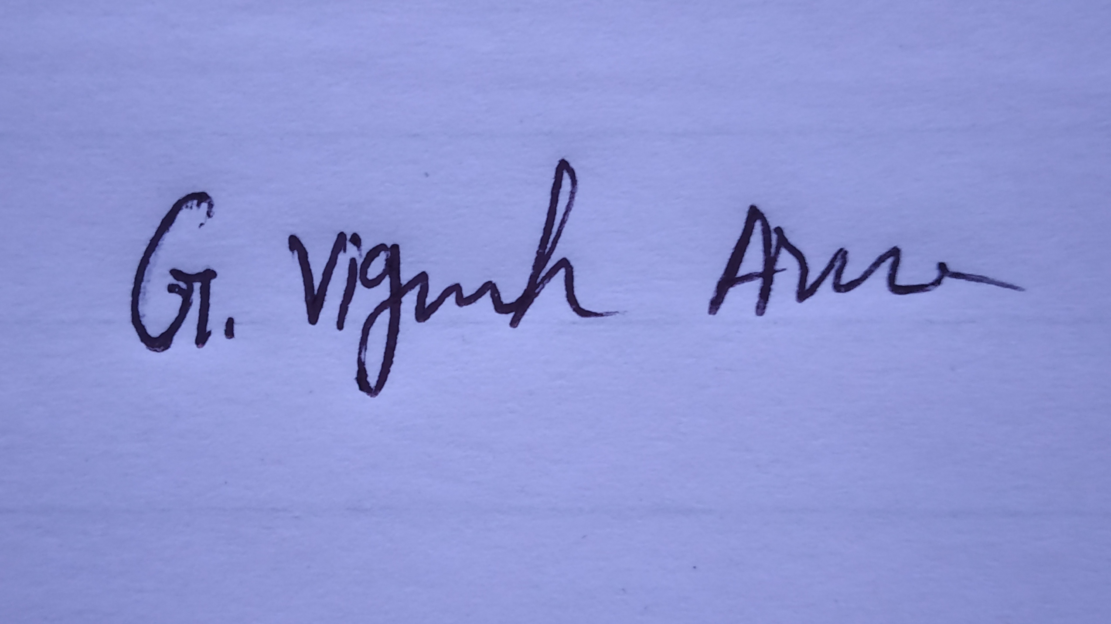
Signed: ________________________
VIGNESH ARVIN
Name in Block Capitals: ________________________
15/12/2021
Date: ________________________

